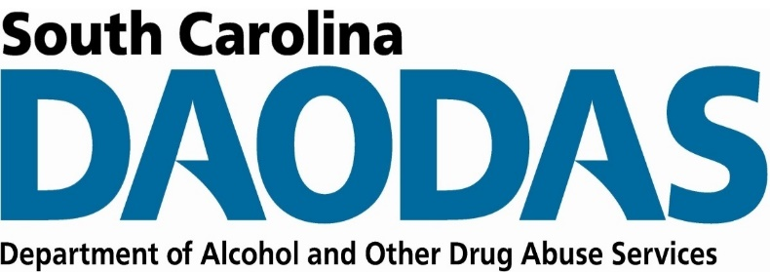
Division of Prevention and Intervention Services
SC DAODAS | 1801 Main Street, 4th Floor, Columbia SC 29201

FY 2021 Prevention SOR 2 Year-End Report
ABC Behavioral Health Center Final Report, December 1, 2020 to September 17, 2021

Strategy Implementation
Instructions: In the table below, please list each Prevention SOR 2 strategy implemented throughout the grant period, December 1, 2020 to September 17, 2021. Also identify the population of focus and total number of people reached per strategy.

Strategy | Specific Strategy Type Implemented | Population | Total Number People Reached
Data Needs and Assessment | Scan/mapping of opioid and stimulant drug issues and resources available in the community. | General Population | 63,661
Education and Awareness | Opioid and stimulant stigma reduction to promote messages that clarify opioid use disorder are diseases and not moral failures or weaknesses | General Population | Billboards: 2,379,992  Digital: 1,380,035

Goals and Objectives
Instructions: Please list each goal and objective. Also indicate the rate, percentage, or number of change per objective to indicate the final outcome or extent to which goals and objectives were achieved.

Goal:
Goal 1: To reduce the number of overdoses related to opioid and/or stimulant use by conducting a community scan/mapping to assess community needs and resources and develop targeted activities for targeted areas.
Goal 2: To increase education and awareness through presentations, media, and printed materials that address substance use as a brain disease and change attitudes and beliefs about substance use to reduce stigma.
Goal Outcome: Preliminary data for ABC County show’s that overdose deaths have increased throughout the pandemic increasing our community’s need for education and awareness.

Objective | Objective Outcome  (Quantify and describe the extent to which objective met.)
Objective 1a: The Prevention Team and volunteers will complete training related to conducting community scan/mapping, as evidenced by certificates and/or verification of completion. | Training related to conducting community scan/mapping was conducted on March 17, 2021 by Proactive Tools. We met with Proactive Tools monthly for seven months.
Objective 1b: The Prevention Team and volunteers will have completed a community scan/mapping and collected all data for zip codes 29405 and 29406, as measured by community scan/mapping outcome data. | The Prevention Team with the help of Proactive Tools gathered data and conducted a community survey. 201 community members participated in the survey.
Objective 2a. The Prevention Team and volunteers will have distributed at least 400 printed materials related to reduction of stigma related to substance use, as measured by information recorded in the monthly implementation summaries. | This objective was not met.
Objective 2b. The Prevention Team will work with ABC County Communications Coordinator to ensure the upload of at least one social media post weekly, as measured by analytics from social media sites. | The Prevention Team working with the ABC County Communications Coordinator was able to post four times on the ABC County Facebook page with 11,999 followers.
Objective 2c. The Prevention Team will have at least 500,000 impressions through targeted displays, as measured by analytics collected by Flagship Media Outdoors. | A total of 2,379,992 people were reached through billboard impressions and a total of 1,380,035 were reached through digital impressions.
Objective 2d. The Prevention Team will have completed at least 6 presentations in each zip code and demonstrate a 10% increase in education/awareness and change in attitudes and beliefs, as measured by data collected from surveys after presentations. | This objective was not met.

Project Narrative

Accomplishments
Instructions: Please share the greatest accomplishments the organization experienced overall.

We worked with Flagship Media Outdoors and reached 1,879,992 more people than we planned with our reducing stigma media campaign.
We received technical assistance from Proactive Tools. Proactive Tools helped us develop our community survey. We surveyed 201 community members and found:
- The majority (62%) of people surveyed thought that there is great risk in using prescription opioids not prescribed to you and only 6% thought there was no risk.
- The majority (66%) of people surveyed thought that there is great risk in using prescription stimulants not prescribed to you and only 5% thought there was no risk.
- 52% of people surveyed dispose of their prescription medications.

Challenges
Instructions: Please share the greatest challenges or barriers the organization experienced overall. Indicate how the organization addressed each challenge or barrier.

Our challenge continues to be the delay in the county process. Due to this delay, we could not start on time, but overall are happy with everything accomplished.

Covid-19 continues to be a challenge. We were not able to meet all our objectives, we pivoted and put more money into our media campaign.
With the results of our community survey, we see the need to implement objective 2a and 2d.
- 56% of the respondents thought that “lack of knowledge about the dangers of opioid and stimulant misuse” is driving the spikes in overdoses.
- While nearly 48% of people thought that sharing medications was a key driver of the spike, only 37% reported having at least a few friends or family members that share their prescription drugs with others or use drugs that were not prescribed to them.
Our hope is to implement objectives 2a and 2d and to use other data collected to guide us in continuing to serve ABC County.

Social media continues to be a challenge for our department. While ABC County has a large following on Facebook we do not always have access to it.

Additional Comments
Instructions: Please share any additional feedback the organization would like to express.

We are grateful for the opportunity and we look forward to continuing to use the data we collected to positively impact our communities.

